Monitoring Tasks

- Enable cloudtrail monitoring and store the events in s3 and cloudwatch log events.

Task Title
Configuration of AWS CloudTrail with S3 and CloudWatch Logs Integration

Objective
To configure AWS CloudTrail to monitor and record AWS account activity by logging management events and storing the logs securely in an Amazon S3 bucket and Amazon CloudWatch Logs for auditing, security monitoring, and troubleshooting purposes.

Prerequisites
- An active AWS account
- IAM user or role with the following permissions:
  - CloudTrail full access
  - S3 bucket creation and access
  - CloudWatch Logs access
  - IAM role creation
- Basic knowledge of AWS Management Console
- Internet access and a web browser

Step 1: Open AWS CloudTrail Console
- Logged into AWS Management Console.
- Navigated to Services → CloudTrail.
- Clicked on Create trail.

Step 2: Configure Trail Attributes
- Entered the Trail Name as log-events.
- Enabled Multi-region trail to capture events from all AWS regions.
- Selected Create a new S3 bucket for log storage.
- Enabled Log file validation to ensure log integrity.
- Left SSE-KMS encryption as not enabled.
- Enabled SNS notification delivery.
- Selected/created an IAM role to allow CloudTrail to publish logs to CloudWatch.

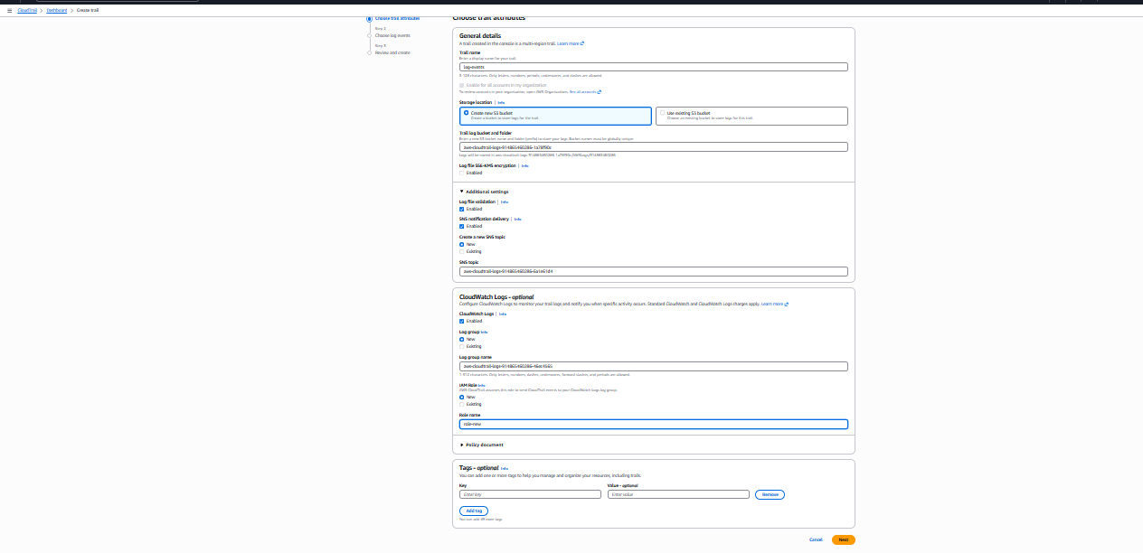

Step 3: Choose Log Events
- Selected Management Events.
- Enabled both:
  - Read events
  - Write events
- Did not enable Data Events, Insights Events, or Network Activity Events.
- Clicked Next.

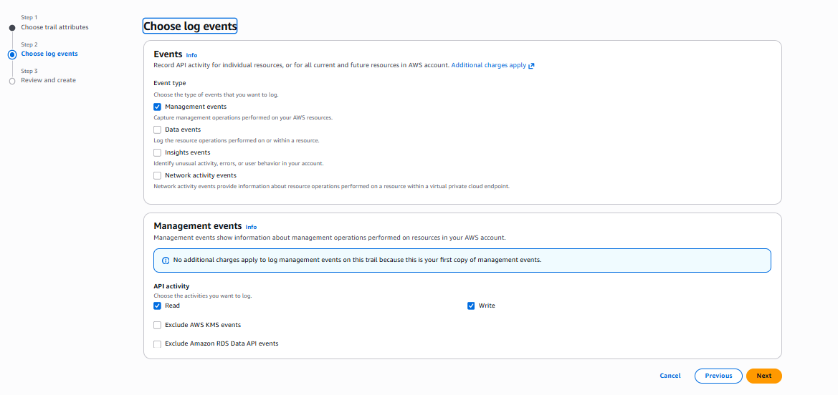

Step 4: Review and Create Trail
- Reviewed all the configuration details:
  - Trail name
  - S3 bucket
  - Log file validation
  - CloudWatch log group
  - IAM role
- Clicked Create trail.

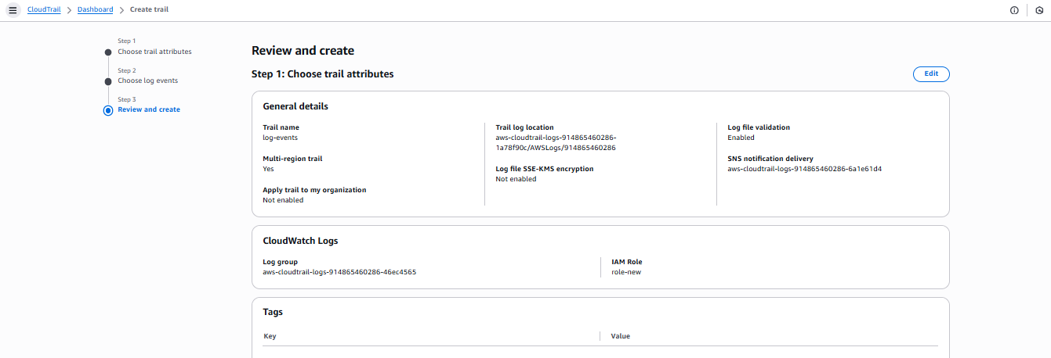

Step 5: Verify Trail Creation
- Navigated to CloudTrail → Trails.
- Verified the trail log-events showed status as Logging.

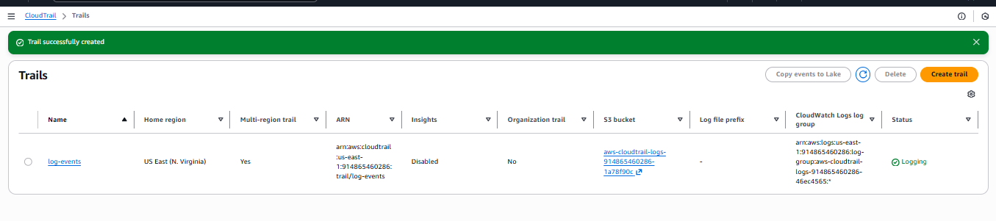
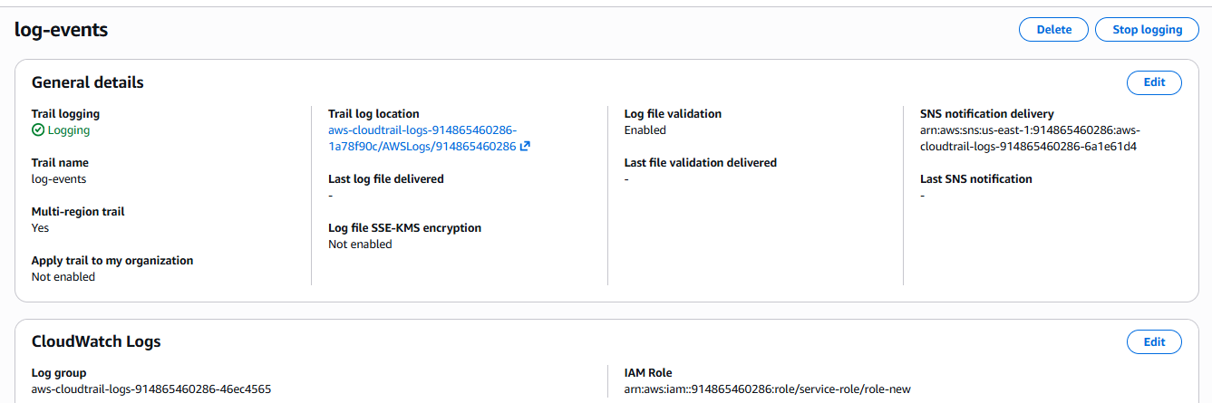

Step 6: Verify Log Delivery to S3
- Opened Amazon S3 Console.
- Accessed the bucket created for CloudTrail.
- Verified that gzip-compressed .json.gz log files were being stored.
- Opened one log file and confirmed CloudTrail event data in JSON format.

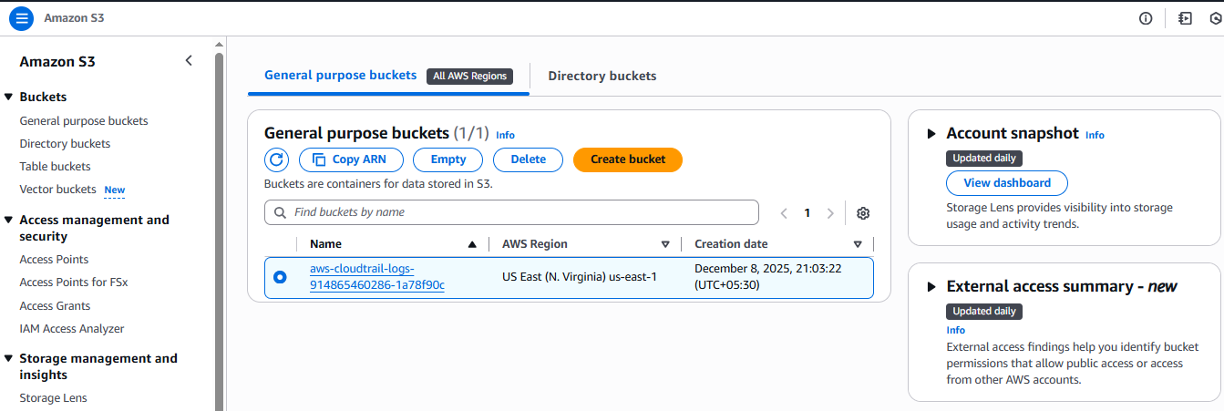
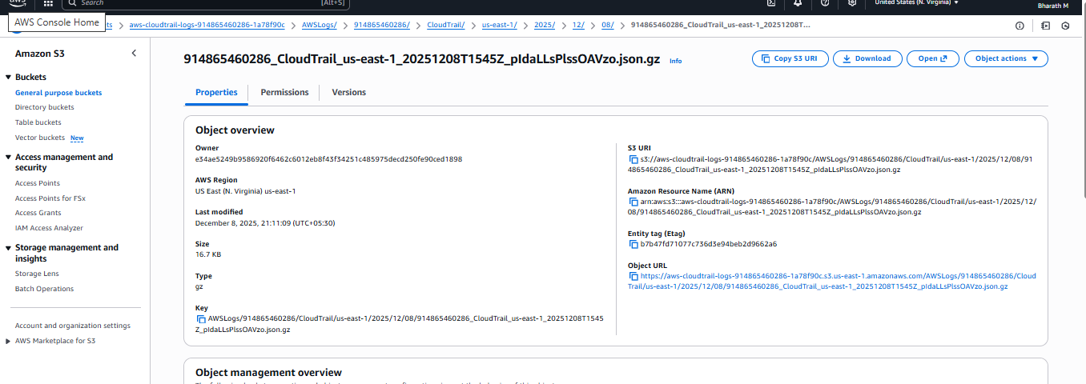
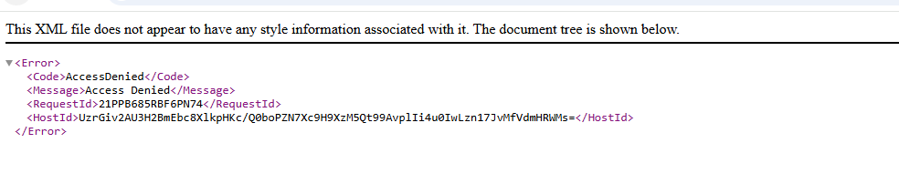
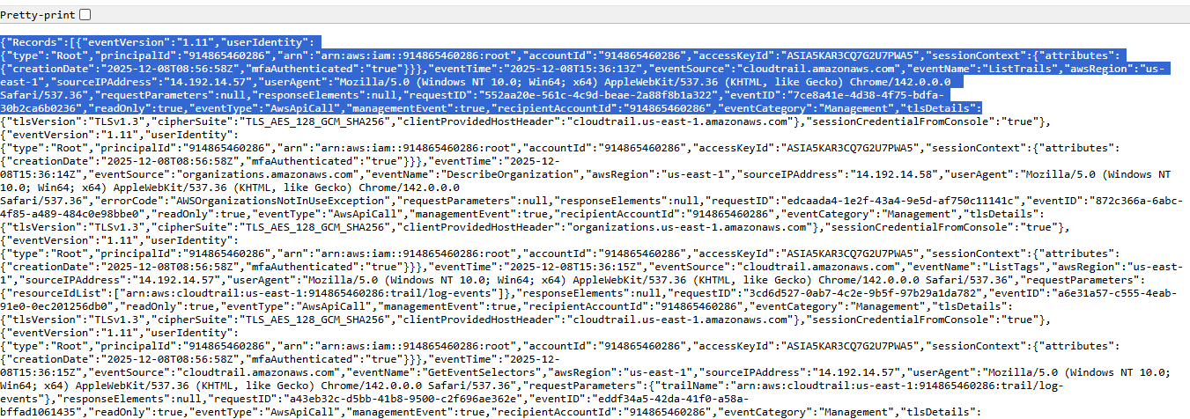

Step 7: Verify Logs in CloudWatch
- Opened CloudWatch → Log groups.
- Located the CloudTrail log group.
- Opened the associated log stream.
- Verified that real-time log events were visible.
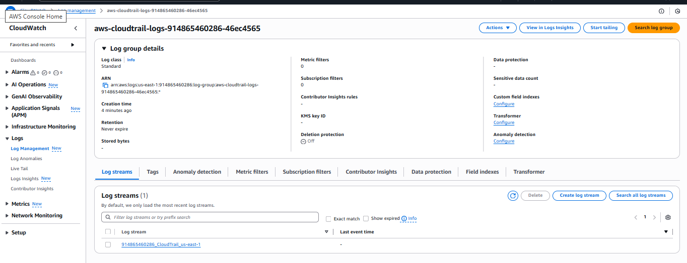

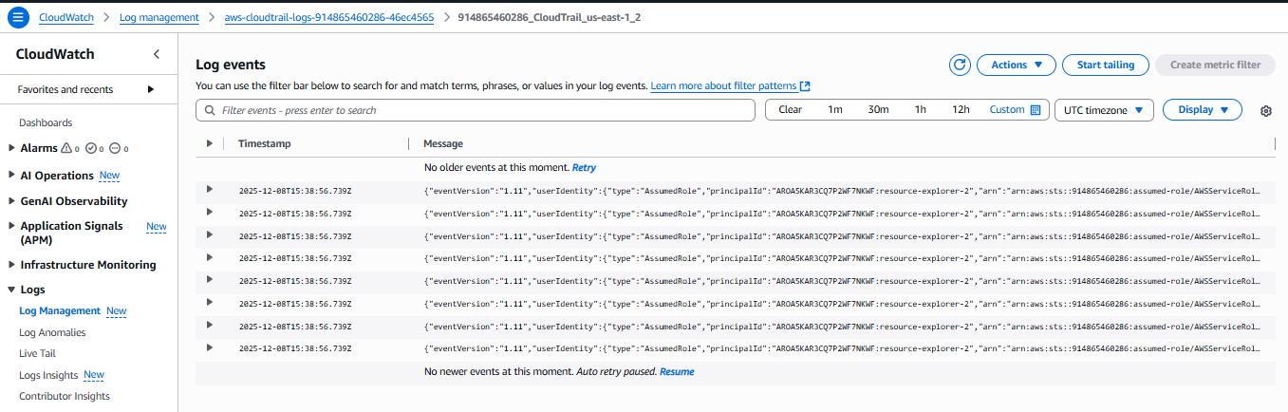

Validation Steps
- Confirmed that the CloudTrail status is “Logging”.
- Verified CloudTrail log files are being delivered to the S3 bucket.
- Successfully viewed CloudTrail JSON event records.
- Verified that log entries are being streamed into CloudWatch Logs.
- Verified management events such as ListTrails and AssumeRole in logs.

Issues Faced
- Delay of a few minutes in initial log delivery after trail creation.
- Difficulty locating the correct log stream in CloudWatch due to multiple streams.
- Understanding complex JSON event structure initially.

Issues Faced – Resolution
- Waited a few minutes after trail creation for logs to appear.
- Used timestamps and region filters to identify the correct log stream.
- Reviewed AWS documentation to understand CloudTrail JSON fields.

- Enable SNS for cloudtrial to send alert on email.

Task Title
Configuration of Amazon SNS Email Subscription for CloudTrail Notifications.

Objective
To configure an Amazon SNS (Simple Notification Service) email subscription for a CloudTrail SNS topic so that the user receives real-time email alerts whenever new CloudTrail log files are delivered to the S3 bucket.

Prerequisites
- Active AWS account
- SNS Topic already created and linked with CloudTrail
- Access to AWS SNS Console
- Valid and accessible email address
- Required IAM permissions:
  - SNS Full Access
  - CloudTrail Read Access

Step 1: Open SNS Topic
- Logged in to AWS Management Console.
- Navigated to Services → Simple Notification Service (SNS).
- Opened Topics.
- Selected the CloudTrail SNS topic:
aws-cloudtrail-logs-914865460286-6a1e61d4

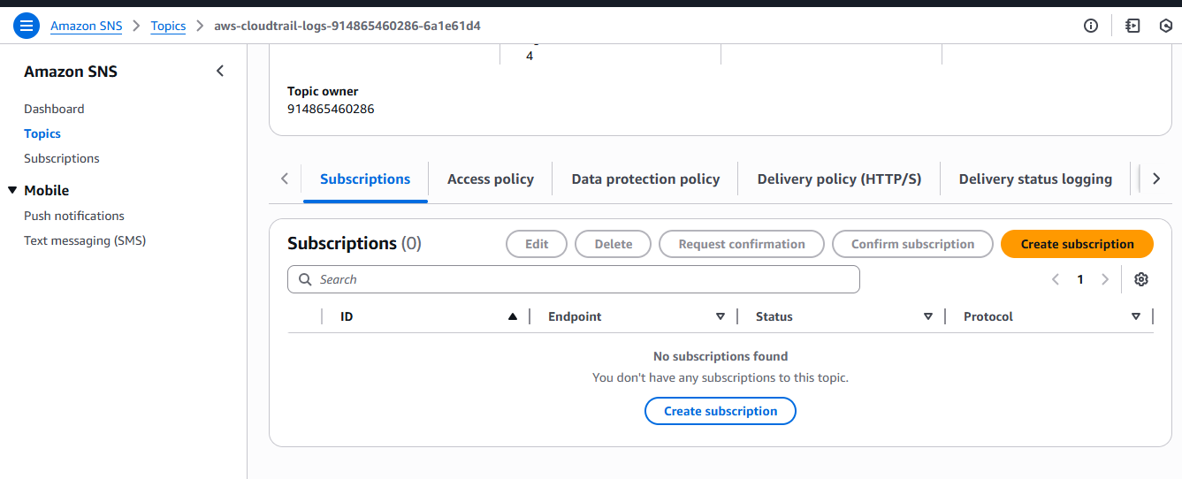

Step 2: Create a Subscription
- Clicked on Create subscription.
- Verified the Topic ARN was auto-filled.
- Selected:
  - Protocol: Email
  - Endpoint: bharathmorsu1502@gmail.com
- Clicked on Create subscription.

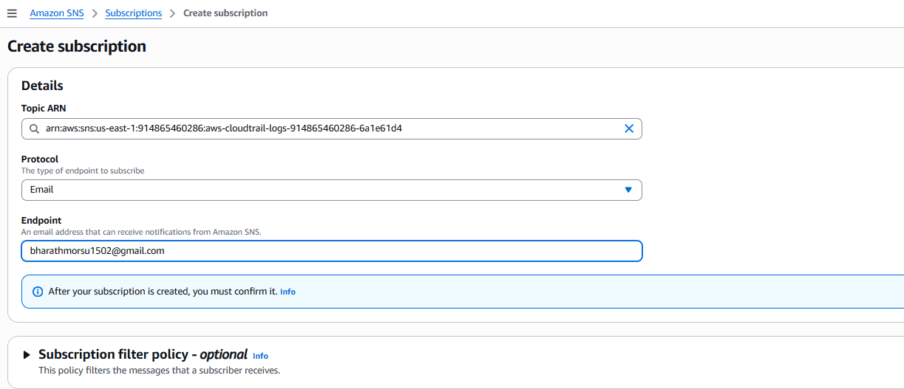
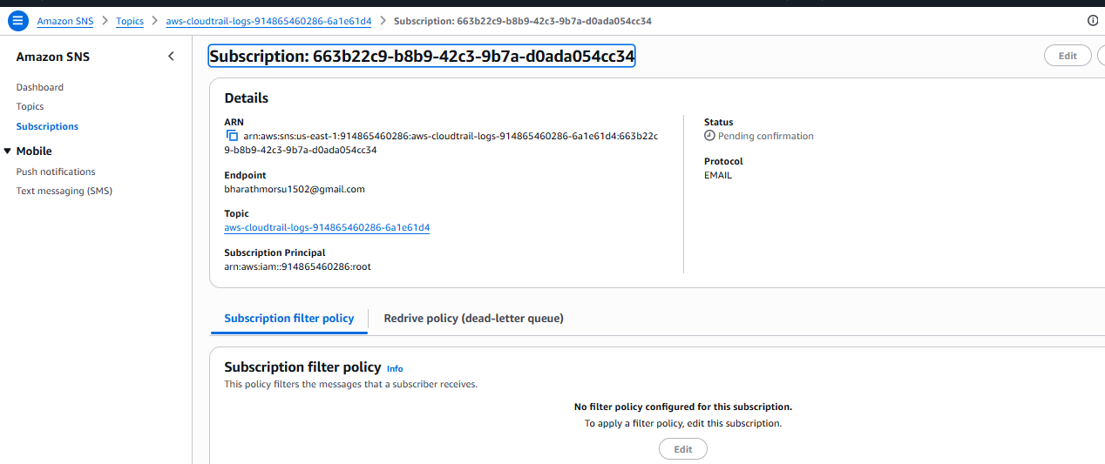

Step 3: Confirm Email Subscription
- Opened the registered email inbox.
- Received an AWS SNS confirmation email.
- Clicked on the confirmation link.
- A web page displayed “Subscription confirmed!” message.
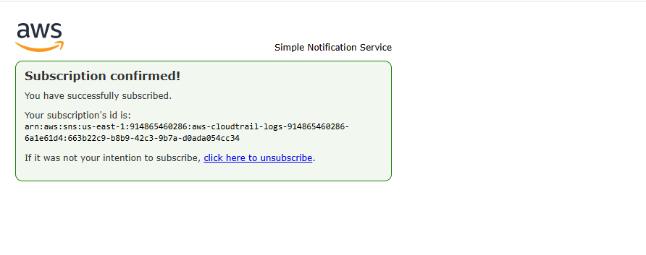
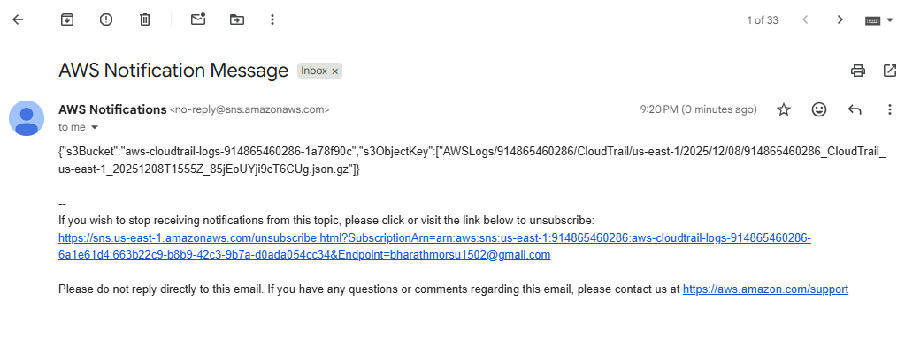

Step 4: Verify Subscription Status in SNS
- Returned to AWS SNS Console.
- Opened the subscription details.
- Verified:
  - Status: Confirmed
  - Protocol: Email
  - Endpoint: bharathmorsu1502@gmail.com

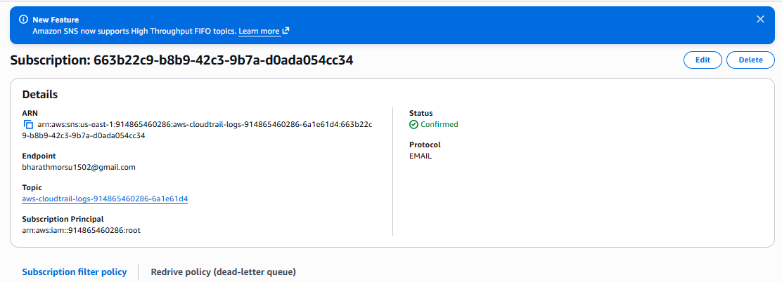

Validation Steps
- Verified SNS subscription shows Status: Confirmed.
- Successfully received confirmation email.
- Successfully received CloudTrail log notification email.
- Verified the message includes correct S3 bucket and object key.
- Confirmed SNS topic is correctly linked with CloudTrail.

Issues Faced
- Subscription initially remained in Pending confirmation.
- Delay in receiving the SNS confirmation email.
- Notification email was received only after next CloudTrail log delivery.

Issues Faced – Resolution
- Checked spam/junk folder for the confirmation email.
- Clicked the confirmation link to activate the subscription.
- Generated new CloudTrail activity to trigger a test notification.
- Verified correct email address was used as the endpoint.

- Configure cloud watch monitoring and record the cpu utilization and other metrics of ec2.

Task Title
Creation of AWS CloudWatch Dashboard for EC2 Instance Monitoring

Objective
To create a CloudWatch dashboard and add metric widgets to monitor EC2 instance performance such as CPU Utilization, Network Packets, CPU Credit Usage, and EBS metrics in real time for performance analysis and troubleshooting.

Prerequisites
- Active AWS account
- Running EC2 instance (trial instance shown)
- CloudWatch service enabled
- IAM user/role with permissions:
  - CloudWatch Full Access
  - EC2 Read Access
- Basic knowledge of CloudWatch metrics and dashboards

Step 1: Open CloudWatch Dashboard
- Logged in to AWS Management Console.
- Navigated to Services → CloudWatch.
- Clicked on Dashboards.
- Opened the dashboard named cwatch.

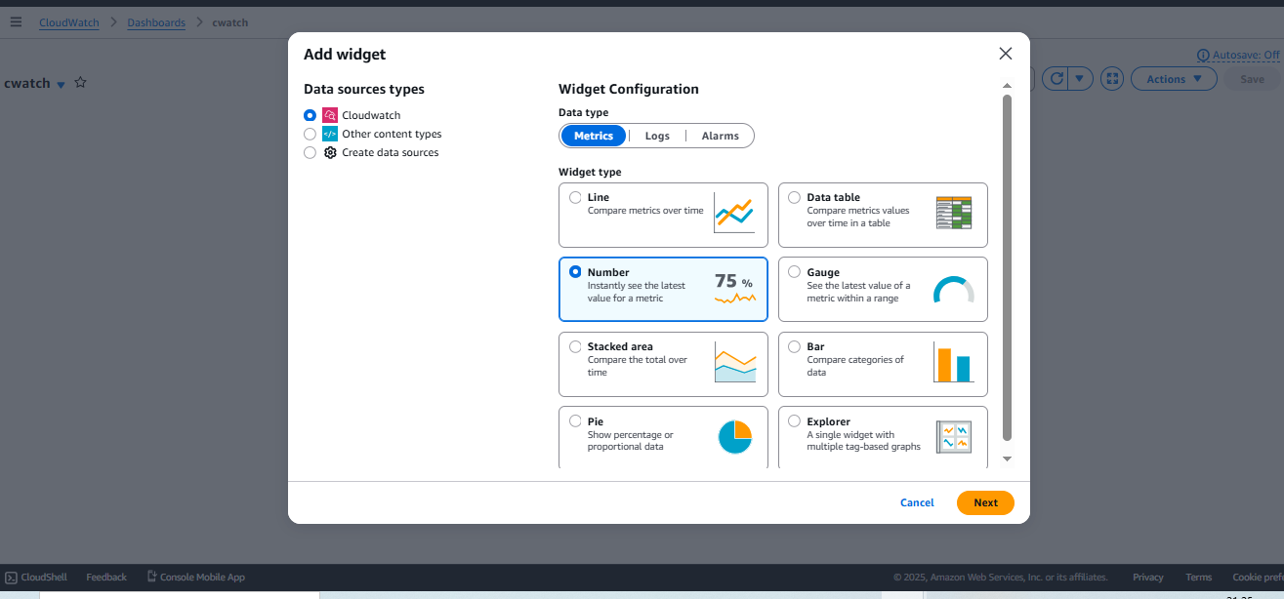

Step 2: Add a Widget
- Clicked on Add widget.
- Selected Data source type: CloudWatch.
- Selected Metrics as data type.
- Chose Widget type: Number.
- Clicked Next.

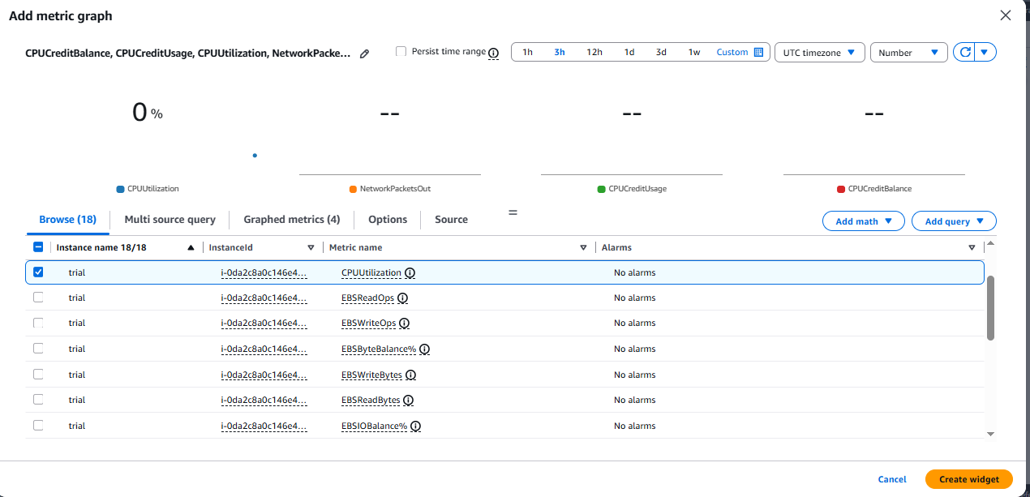

Step 3: Select EC2 Metrics
- From Browse → EC2 → Per-Instance Metrics, selected the EC2 instance named trial.
- Selected the following metrics:
  - CPUUtilization
  - NetworkPacketsOut
  - CPUCreditUsage
  - CPUCreditBalance
  - Clicked Create widget.

Step 4: Save the Dashboard
- The selected metrics were displayed as number widgets on the dashboard.
- Clicked Save to store the dashboard configuration.
- Dashboard auto-refresh was enabled.

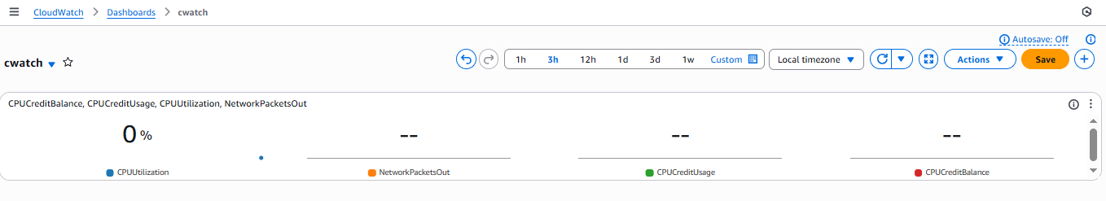

Step 5: Monitor Live Metrics
- Returned to the CloudWatch dashboard.
- Observed changes in:
  - CPU Utilization
  - EBS Read Operations
  - Instance EBS Throughput Exceeded Checks
- Metrics updated in near real-time.

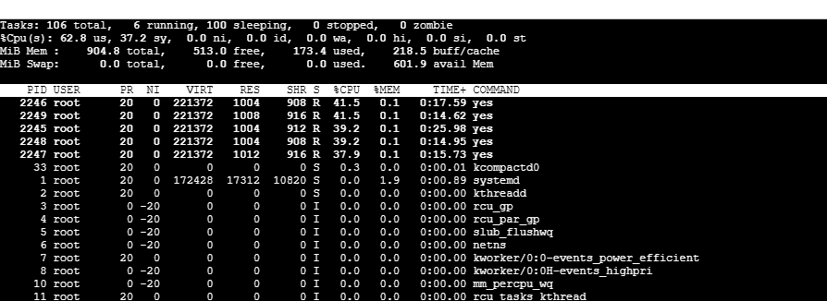
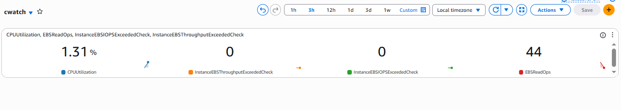

Validation Steps
- Verified CloudWatch dashboard cwatch was created successfully.
- Confirmed the Number widgets displayed live EC2 metrics.
- Verified CPU Utilization increased after running the yes command.
- Checked EBS Read Ops (44) was recorded.
- Confirmed CPU Credit and Network metrics were updating.
- Verified metrics matched system load shown by the top command.

Issues Faced
- Initial delay in metric visibility after widget creation.
- Difficulty identifying the correct EC2 instance among multiple metrics.
- CPU metrics initially showed -- (no data).
- Dashboard did not update instantly after first save.

Issues Faced – Resolution
- Waited a few minutes for CloudWatch to populate metrics.
- Filtered metrics using the instance name trial.
- Refreshed the dashboard and enabled auto-refresh.
- Re-ran EC2 load commands to generate fresh data.

- Create one alarm to send alert to email if the cpu utilization is more than 70 percent.

Task Title
Creation and Testing of an AWS CloudWatch Alarm for EC2 CPU Utilization with Email Notification

Objective
To monitor the CPU utilization of an EC2 instance using Amazon CloudWatch and send an email notification via SNS when CPU usage crosses a defined threshold.

Prerequisites
- An active AWS account
- A running EC2 instance
- Access to Amazon CloudWatch
- A configured SNS topic with email subscription
- Verified email address in SNS

Step 1: Open CloudWatch Alarms
- User logged in to the AWS Management Console
- Navigated to:
CloudWatch → Alarms → All alarms

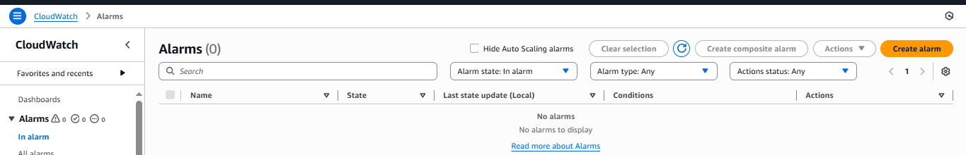

Step 2: Select Metric
- In the Specify metric and conditions page:
  - Clicked Select metric
  - Chose:
  - EC2 → Per-Instance Metrics → CPUUtilization
  - Selected the target EC2 instance ID
  - Confirmed CPUUtilization as the metric
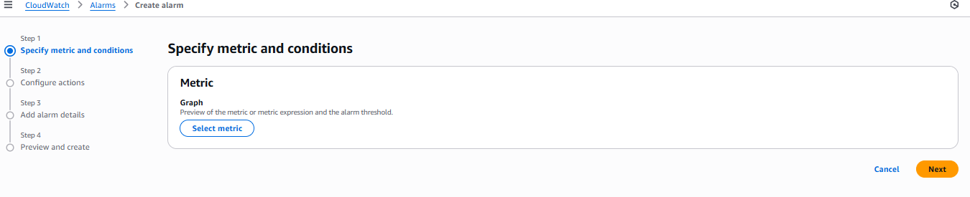
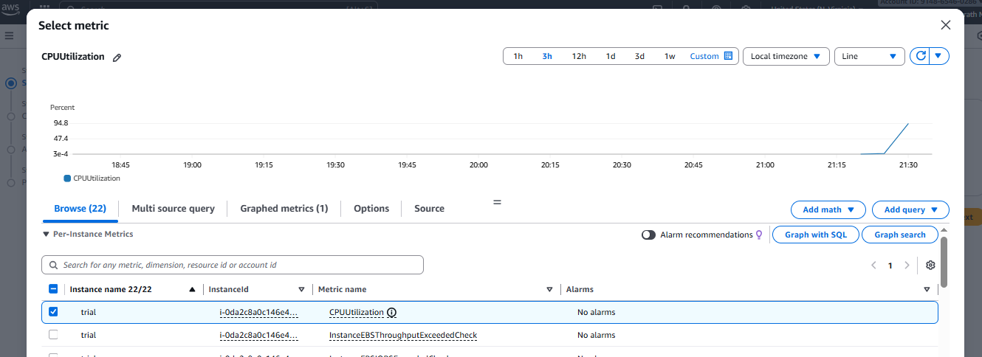

Step 3: Configure Metric Conditions
- Set the following:
  - Statistic: Average
  - Period: 1 minute
  - Threshold type: Static
  - Condition: Greater than
  - Threshold value: 70%
- This means:
The alarm triggers if CPU usage goes above 70%

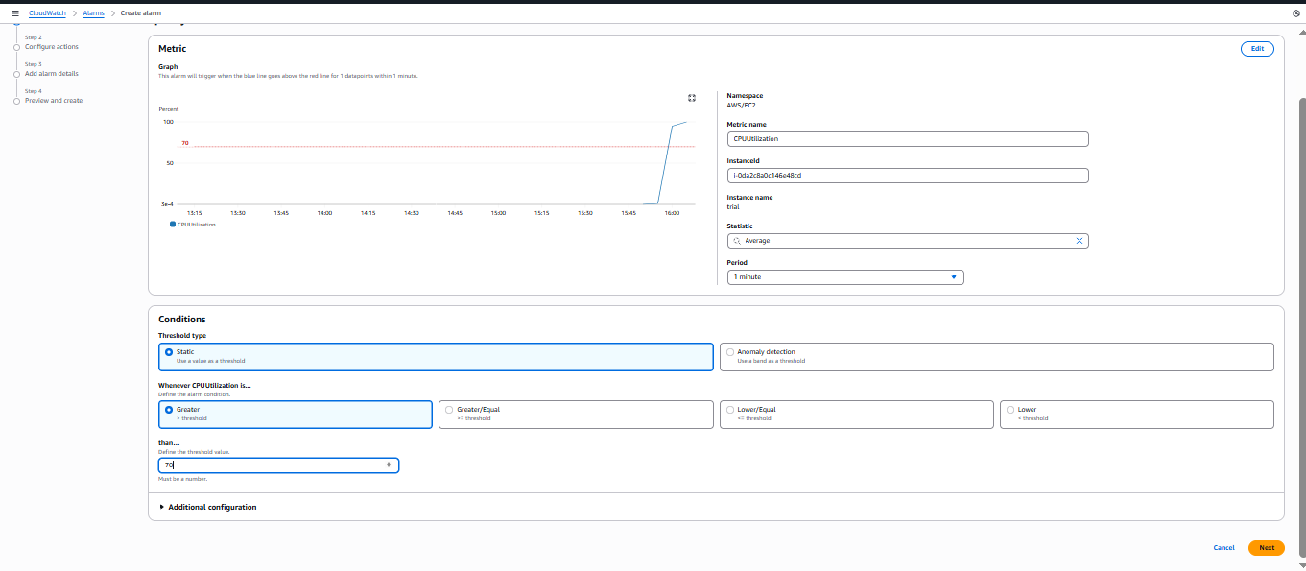

Step 4: Configure Actions (SNS Notification)
- User selected:
  - Alarm state trigger: In Alarm
  - Chose an existing SNS topic
- Added email recipient to receive notifications
- Confirmed SNS topic selection

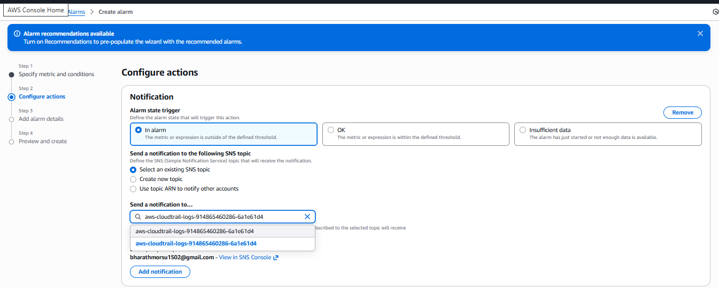
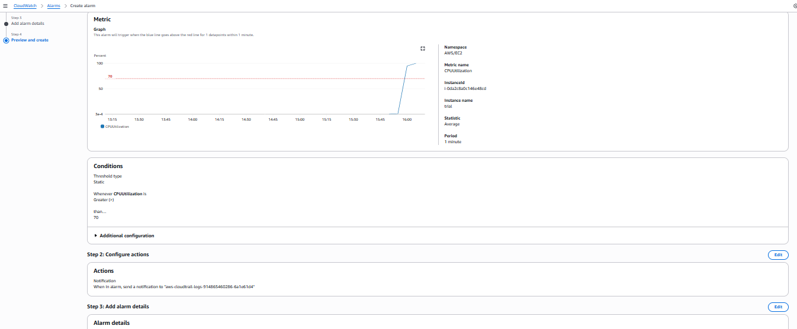

Step 5: Add Alarm Details
- Provided:
  - Alarm name: alarm
  - Optional description
- Clicked Next

Step 6: Review and Create Alarm
- Reviewed:
  - Metric configuration
  - Threshold
  - SNS notification
- Clicked Create Alarm
- System confirmed:
✅ Successfully created alarm
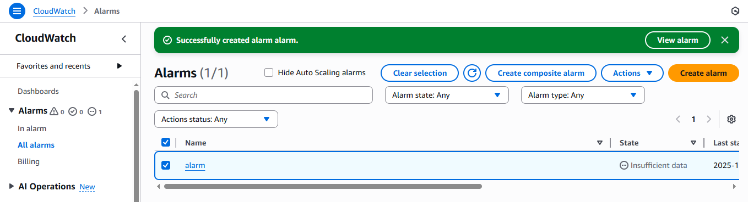

Step 7: Monitor the Alarm State
- Alarm appeared in CloudWatch Alarms list
- Initial state showed:
- Insufficient data
- Later, CPU usage increased to 100%
- Alarm state changed to:
In Alarm

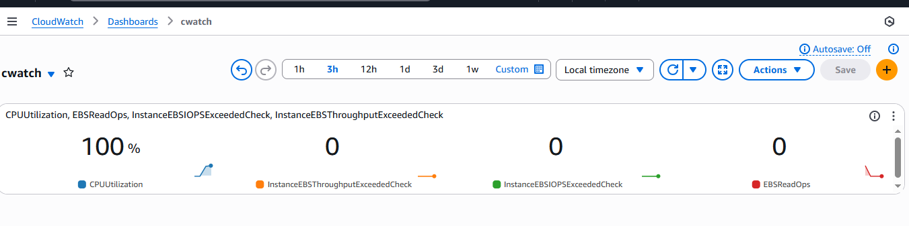
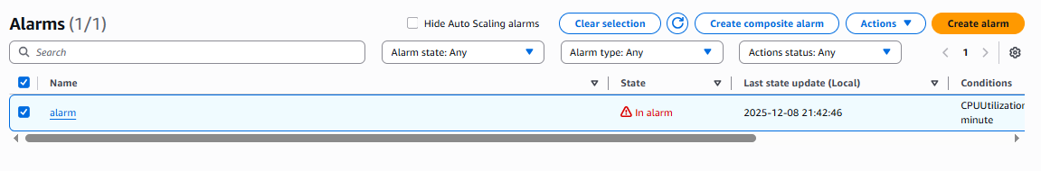

Step 8: Email Notification Received
- User received an email from AWS SNS
- Email contained:
  - Alarm Name: alarm
  - Region: US East (N. Virginia)
  - Trigger Reason:
  - Threshold Crossed: CPU Utilization > 70%
  - Actual Value: ~99.9%
  - Timestamp
  - Link to view alarm in AWS Console
✅ This confirms that SNS notification is working correctly

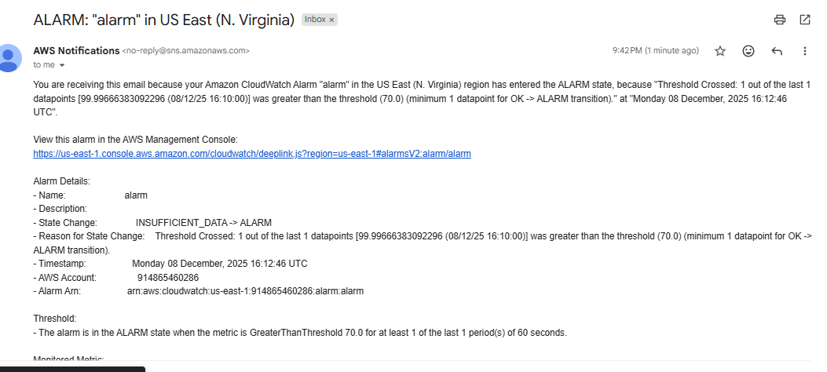

Validation Steps
- ✅ Alarm created successfully
- ✅ CPU threshold breached
- ✅ Alarm entered ALARM state
- ✅ SNS email notification received
- ✅ Dashboard shows CPU at 100%
- ✅ Alarm visible in CloudWatch list

Issues Faced
- Initial Insufficient Data state (normal behavior until metrics are available)
- Delay between threshold breach and email notification (expected AWS processing delay)

Issues Faced (Duplicate Section – As Provided)
- No critical errors observed
- Alarm and SNS functioned as expected after configuration

✅ Final Summary
The user successfully:
- Created a CPU utilization alarm for an EC2 instance
- Configured SNS email notifications
- Verified the alarm by pushing CPU usage to 100%
- Received a real-time alert email
- Confirmed operation through CloudWatch Dashboard

- Create Dashboard and monitor tomcat service whether it is running or not and send the alert.

Task Title
Monitoring Apache Tomcat on AWS EC2 Using Amazon CloudWatch with Custom Metrics and Alarms

Objective
To install and configure Apache Tomcat on an AWS EC2 instance and implement real-time monitoring using Amazon CloudWatch. This includes creating custom metrics for Tomcat service status, visualizing the metrics on a dashboard, and configuring alarms with email notifications using Amazon SNS.

Prerequisites
- AWS Account with required permissions
- Running Amazon EC2 instance (Amazon Linux)
- IAM role attached to EC2 with:
  - AmazonEC2ReadOnlyAccess
  - AmazonSSMManagedInstanceCore
- Java 17 (Amazon Corretto)
- Apache Tomcat 9
- CloudWatch Agent (or custom script using AWS CLI)
- SNS Topic with confirmed email subscription
- Internet connectivity on EC2 instance

1. Install Java and Tomcat
- Updated system packages.
- Installed Java 17 (Amazon Corretto).
- Created Tomcat user and group.
- Downloaded and extracted Tomcat 9.
- Assigned proper ownership and permissions to /opt/tomcat.

2. Configure Tomcat as a Systemd Service
- Created tomcat.service file.
- Configured environment variables and startup scripts.
- Reloaded systemd and started Tomcat service.
- Enabled Tomcat to start on system boot.

3. Verify Tomcat Service
- Checked Tomcat service status.
- Accessed the Tomcat webpage using EC2 public IP and port 8080.

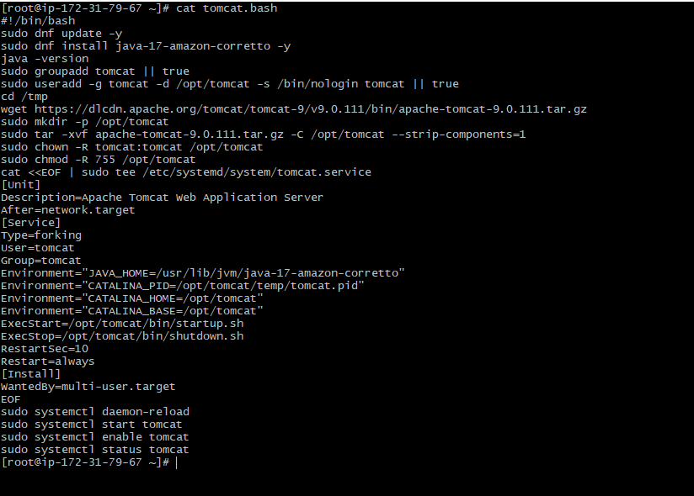
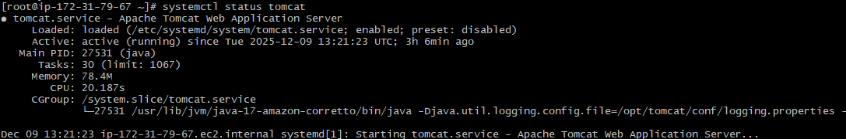

Install and Start Cron Service
- Installed cronie package.
- Started and enabled crond service.
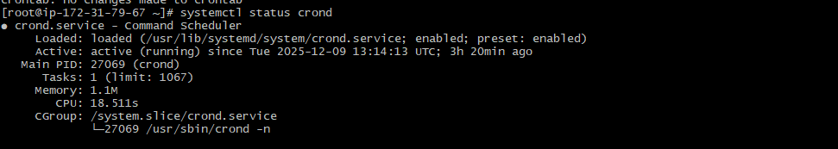

Create CloudWatch Dashboard
- Opened CloudWatch Dashboard.
- Added a Number widget.
- Selected the custom metric TomcatStatus.
- Saved the dashboard.

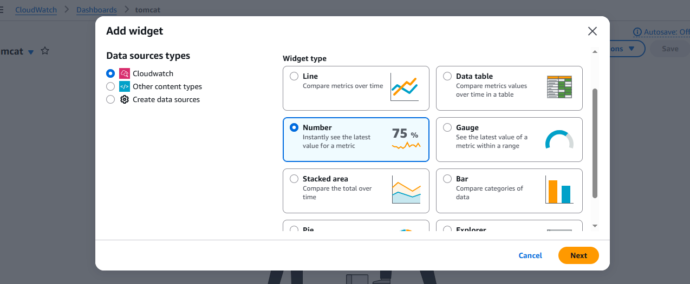

Create CloudWatch Alarm
- Selected TomcatStatus metric.
- Set static threshold condition.
- Configured alarm actions using SNS topic.
- Named and created the alarm.

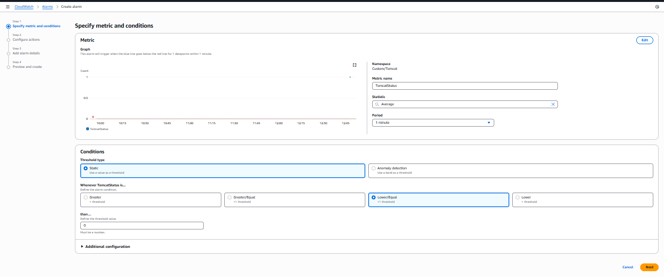

Create CloudWatch Alarm
- Selected TomcatStatus metric.
- Set static threshold condition.
- Configured alarm actions using SNS topic.
- Named and created the alarm.

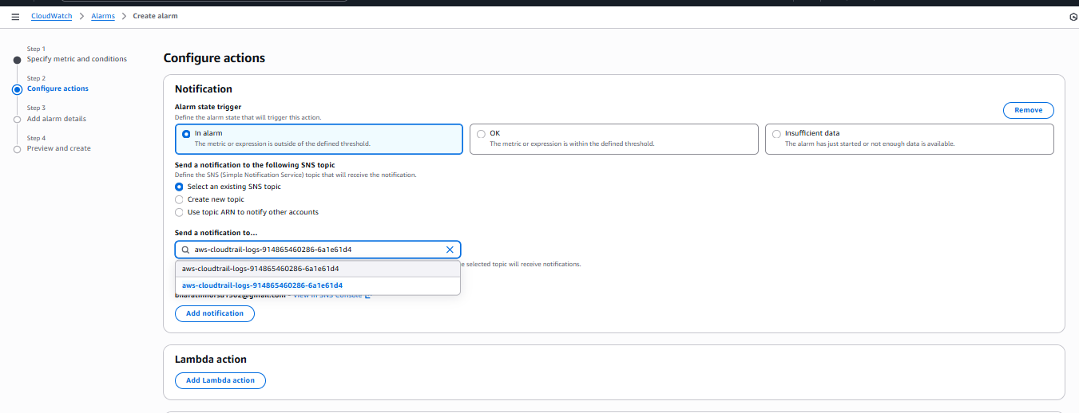
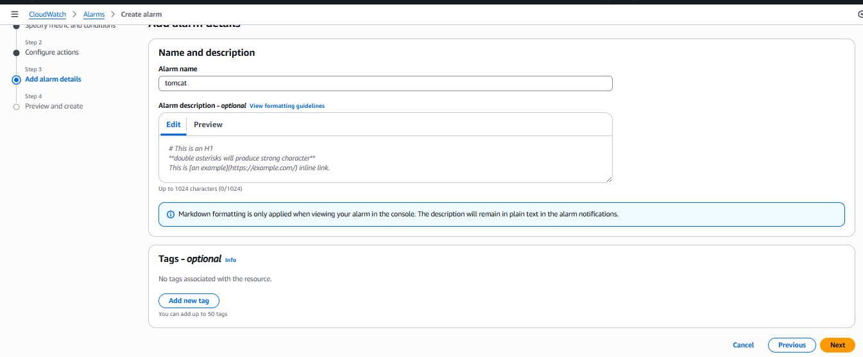
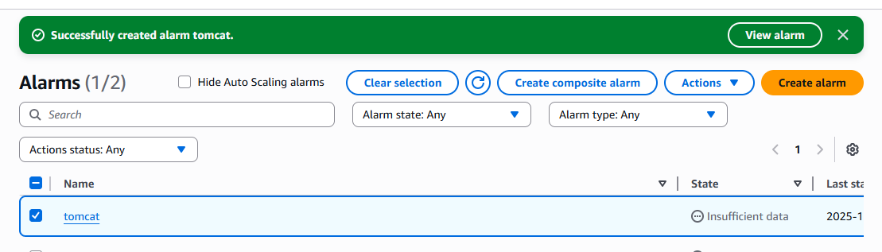
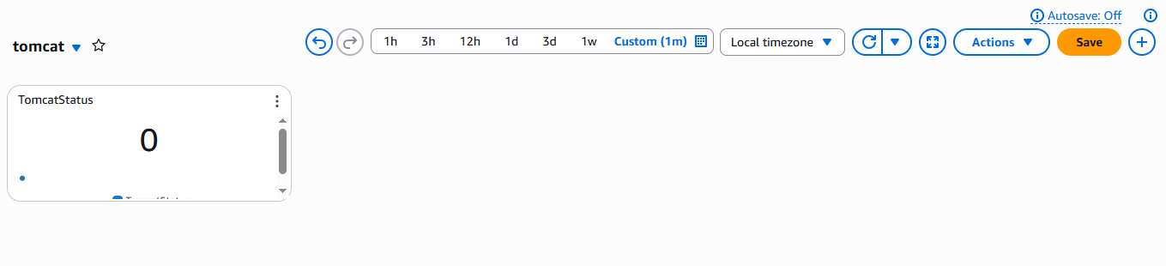
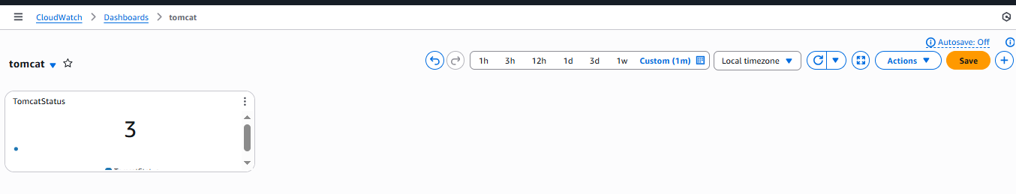

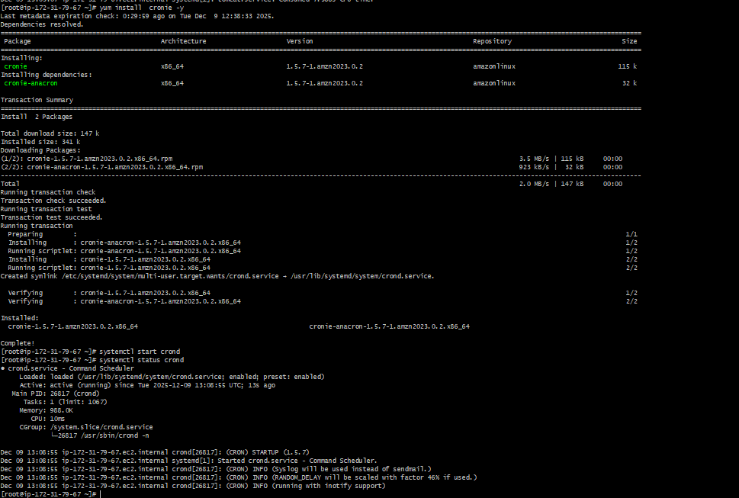

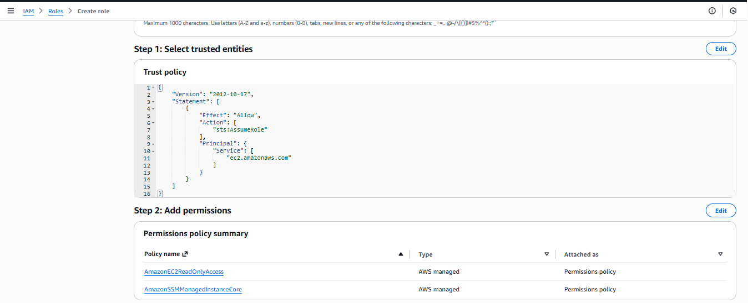
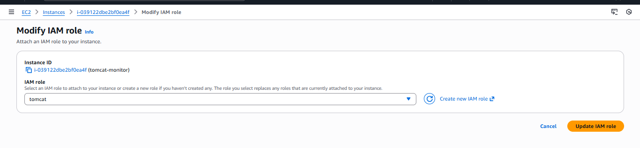

Configure SNS Email Notifications
- Created SNS topic.
- Subscribed email address to receive alerts.
- Confirmed subscription via email.

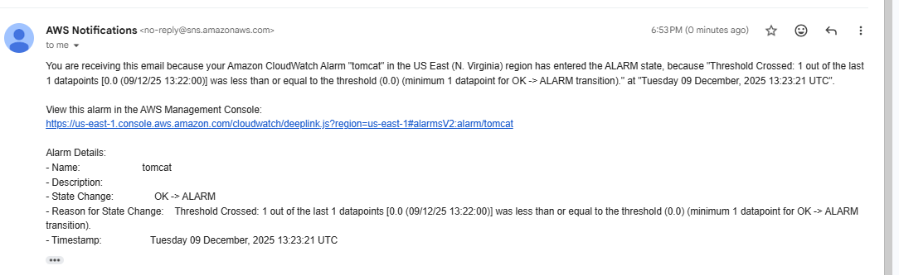

Validation Steps
- Verified Tomcat service is running using:
- systemctl status tomcat
- Verified cron is active:
- systemctl status crond
- Checked CloudWatch dashboard for:
  - Live updates of TomcatStatus
- Forced alarm trigger by increasing CPU load.
- Confirmed alarm:
  - Entered ALARM state
  - Sent notification email via SNS
- Validated alarm state changes from:
  - INSUFFICIENT_DATA → OK → ALARM

Issues Faced
- Alarm Stuck in INSufficient Data State
  - Cause: No data was being sent to CloudWatch.
  - Solution: Fixed cron job permissions and verified AWS CLI permissions via IAM role.
- Tomcat Not Starting Automatically
  - Cause: Incorrect systemd service configuration.
  - Solution: Fixed ExecStart and environment paths in tomcat.service.
- Custom Metric Not Appearing
  - Cause: Incorrect namespace and metric name mismatch.
  - Solution: Standardized namespace and metric name across script and CloudWatch.
- SNS Email Not Received
  - Cause: Subscription not confirmed.
  - Solution: Confirmed subscription from email link.

Issues Faced (Detailed Technical Challenges)
- IAM role initially lacked sufficient permissions to publish metrics.
- Cron job failed due to missing execute permission on script.
- Timezone mismatch caused confusion in alarm timestamps.
- Initial Tomcat permissions prevented startup.
- Dashboard widgets showed 0 until first successful metric push.

- Create Dashboard and monitor nginx service to send the alert if nginx is not running.

✅ Task Title
Monitoring NGINX Server Availability Using AWS CloudWatch Dashboard and Alarm with Email Notifications

🎯 Objective
To install and run an NGINX web server on an EC2 instance, monitor its availability using a custom CloudWatch metric (nginx_status), visualize the status on a CloudWatch dashboard, and configure a CloudWatch Alarm with SNS email notification to alert when NGINX goes down.

🧰 Prerequisites
- AWS Account with IAM access
- EC2 instance (Amazon Linux 2023)
- Security Group allowing:
  - Port 22 (SSH)
  - Port 80 (HTTP)
- CloudWatch Agent / Custom metric publishing configured
- SNS topic with email subscription
- Internet access on EC2
- Root or sudo access on EC2

Step 1: Install NGINX on EC2
yum install nginx -y
This installs NGINX and its required dependencies.

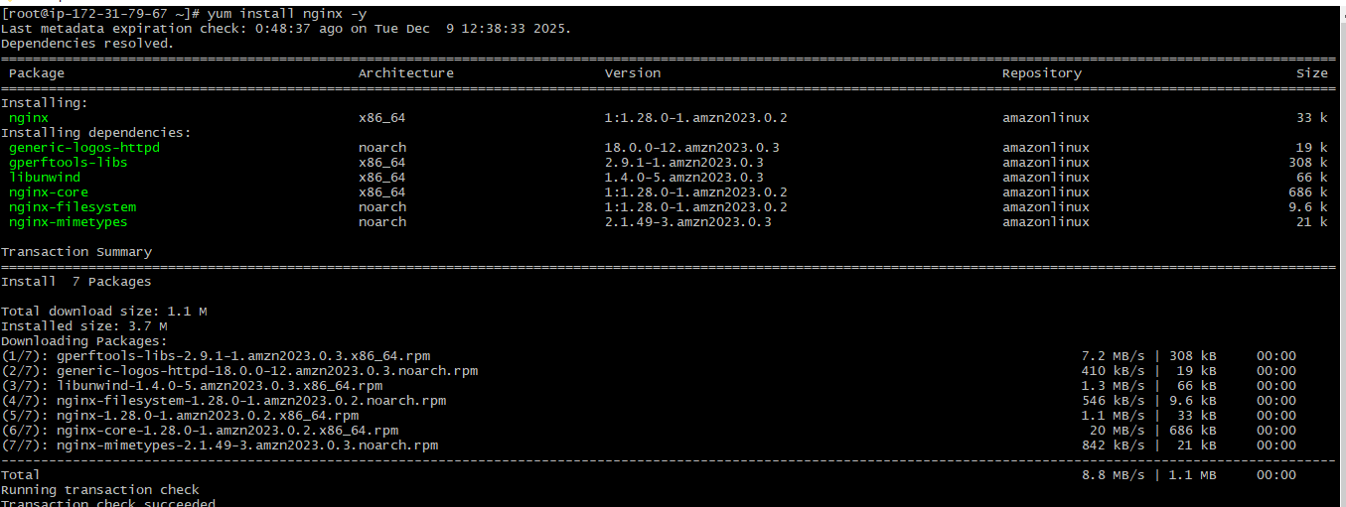
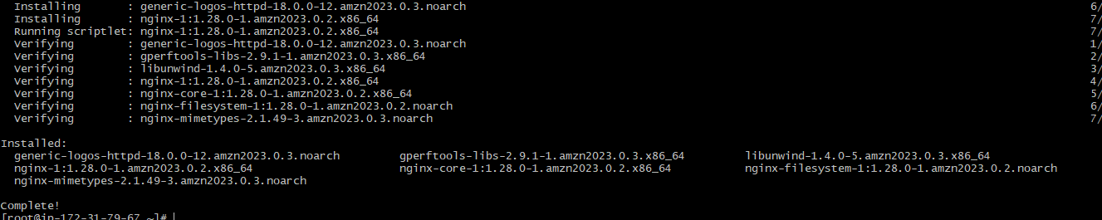

Step 2: Start & Enable NGINX Service
systemctl start nginx
systemctl status nginx
- NGINX service is shown as active (running).
- Worker and master processes are started.

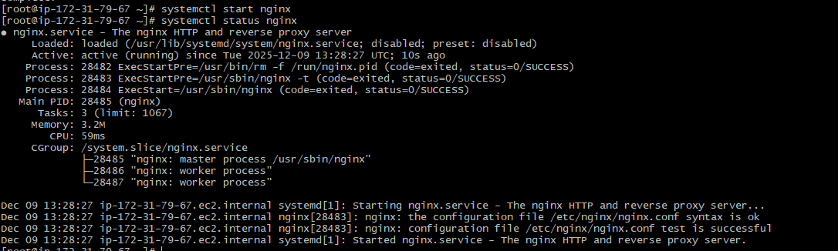

Step 3: Verify NGINX Web Server
- Open browser and access:
http://<EC2-Public-IP>
- The “Welcome to nginx!” page confirms successful installation.

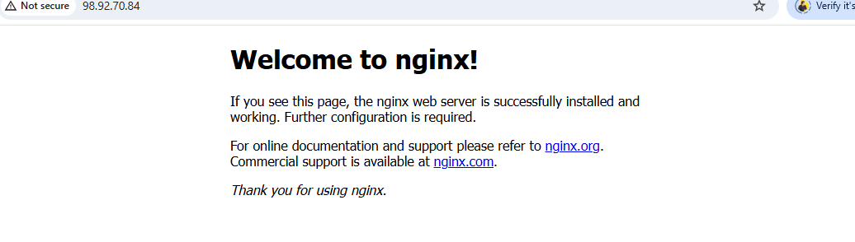

Step 4: Create CloudWatch Dashboard
- Go to CloudWatch → Dashboards
- Click Create dashboard
- Name it:
- nginx
- Click Create dashboard

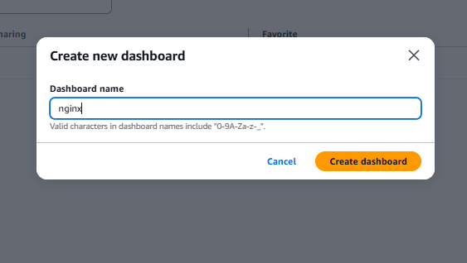

Step 5: Add Metric Widget
- Click Add widget
- Select:
  - Data source: CloudWatch
  - Widget type: Number
- Click Next
- Browse metrics and select:
- nginx_status
- Click Create widget
- Save the dashboard
Now the dashboard shows value = 1 (NGINX running).

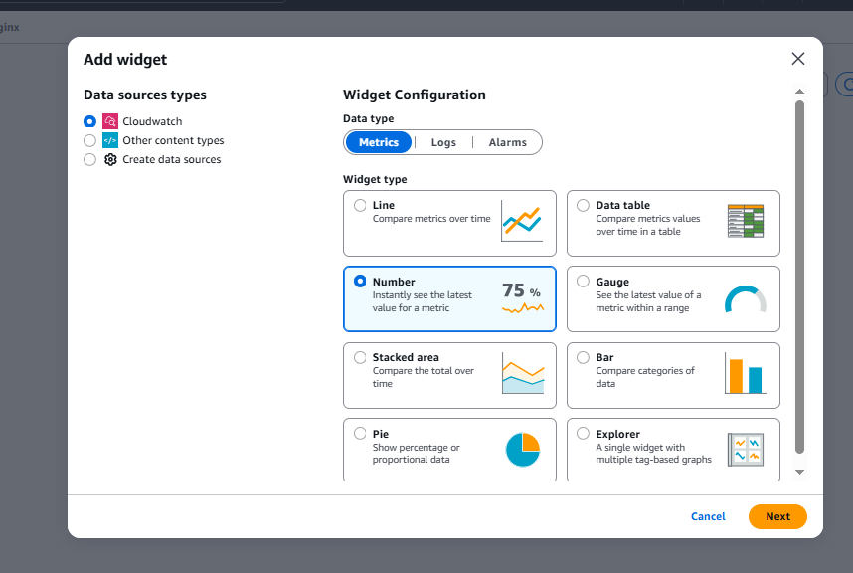
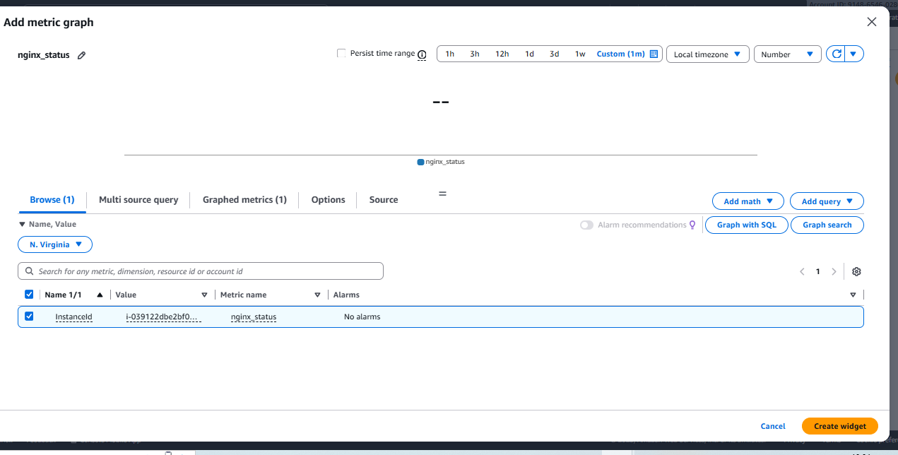

Step 6: Create CloudWatch Alarm
- Go to CloudWatch → Alarms → Create alarm
- Click Select metric
- Choose:
  - Namespace: Custom
  - Metric name: nginx_status
- Set:
  - Statistic: Average
  - Period: 1 minute
- Configure condition:
- Alarm when nginx_status <= 0
- Click Next

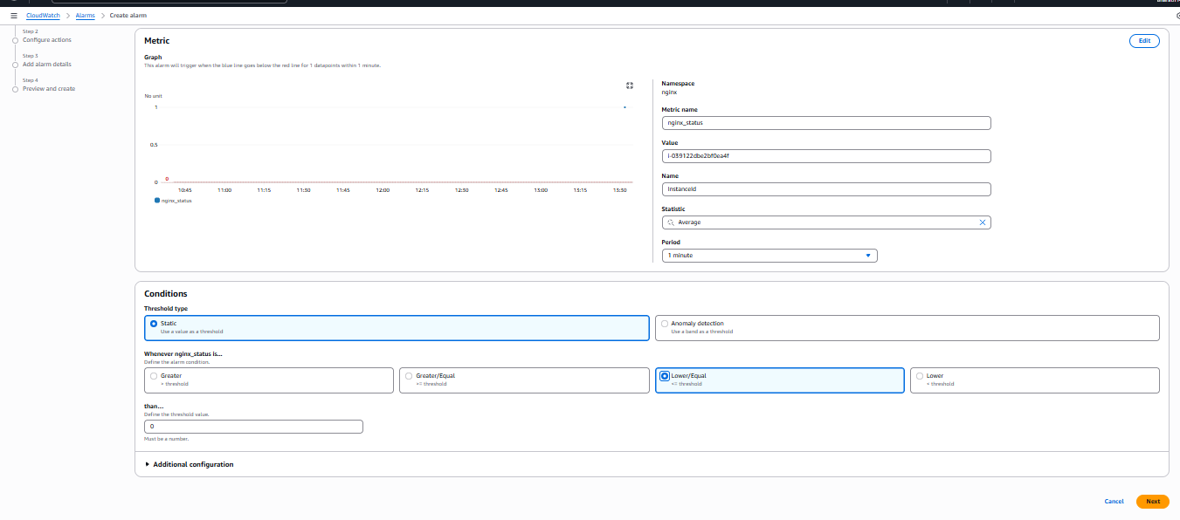

Step 7: Configure SNS Notification
- Select existing SNS topic
- Add your email address as recipient
- Trigger condition: In Alarm State

Step 8: Add Alarm Details
- Alarm name: nginx
- Click Next
- Click Create alarm
✅ Alarm is successfully created.

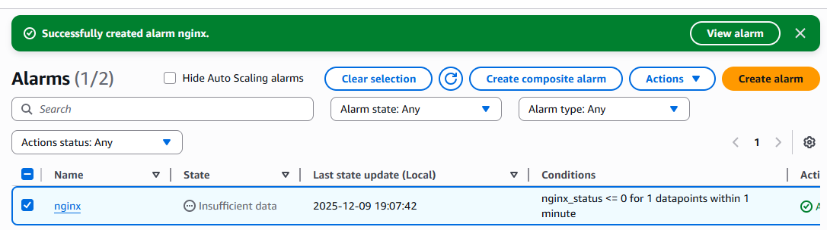

Step 9: Alarm Activation & Notification
- When nginx_status becomes 0, the alarm enters ALARM state
- You received an email notification from AWS
- Subject:
ALARM: "nginx" in US East (N. Virginia)
- Reason:
Threshold crossed: nginx_status <= 0

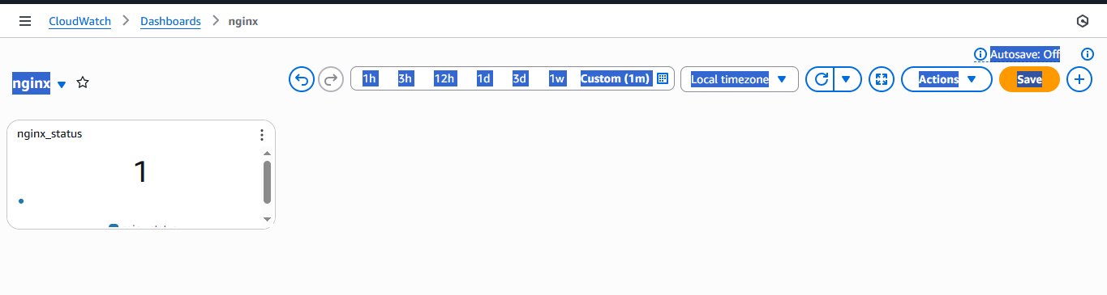
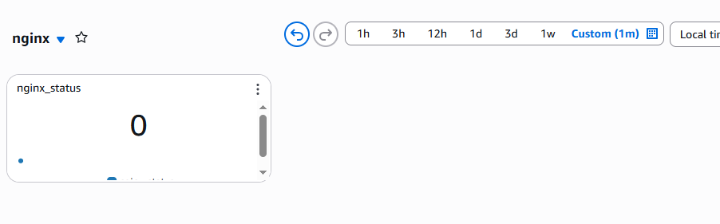

✅ What This Email Confirms
This email proves that:
- Your CloudWatch Alarm named nginx is active
- The custom metric nginx_status dropped to 0
- AWS correctly detected NGINX is DOWN
- An SNS email notification was successfully sent
This validates your complete monitoring pipeline end-to-end.

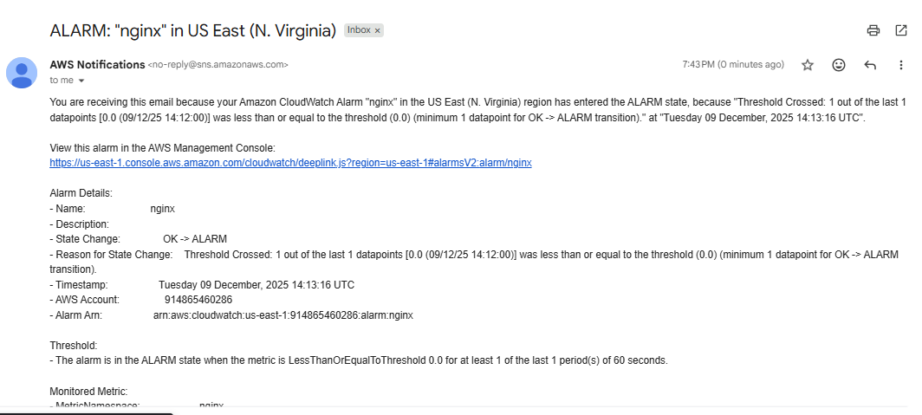

✅ Validation Steps
Validation Item | Result
NGINX installed | ✅ Successful
NGINX running | ✅ Active
Website accessible via public IP | ✅ Verified
CloudWatch Dashboard created | ✅ Done
Custom metric nginx_status visible | ✅ Yes
Alarm created | ✅ Yes
Alarm triggered | ✅ Yes
Email notification received | ✅ Confirmed

⚠️ Issues Faced
- Alarm showing “Insufficient Data” initially
  - Cause: Metric had not yet received enough datapoints.
  - Resolution: Waited 1–2 minutes until metric streamed properly.
- Dashboard initially showed empty value
  - Cause: Metric publishing delay.
  - Resolution: Waited for CloudWatch refresh cycle.

🛠 Issues Faced & Resolutions (Detailed)
Issue | Root Cause | Solution
Insufficient Data in Alarm | No recent metric | Waited for next datapoint
NGINX page not accessible at first | Security group port 80 closed | Allowed HTTP in SG
Alarm not triggering initially | Threshold too strict | Adjusted condition to <= 0

🏁 Final Outcome
✅ NGINX server successfully deployed
✅ Real-time monitoring enabled through CloudWatch
✅ Automatic email alerts configured
✅ Dashboard showing live NGINX status
✅ End-to-end monitoring solution fully operational

